ADMINISTRATIVE POLICY MANUAL

TITLE: Credit and Collection | POLICY NUMBER: SHS-ADM-073
POLICY DATE: July 13, 2020 | EFFECTIVE DATE: September 15, 2020
REVISION DATES: October 26, 2020 | REVISION EFFECTIVE: November 15, 2020
REVIEW DATES:

PURPOSE:

The mission of Southcoast Health System (SHS) is to care for and improve the health, and to promote the wellness, of the individuals and communities it serves. SHS is an integrated health care system that provides health care services through affiliated provider entities: Southcoast Hospitals Group, Inc. (SHG), Southcoast Physicians Group, Inc. (SPG), and Southcoast Visiting Nurse Association, Inc. (SCVNA).

This Policy is intended to provide SHS patients with information about the respective financial assistance and collection policies of SHG, SPG, and SCVNA, respectively, and to establish consistent credit and collection practices throughout SHS.

This Policy applies to SHG, SPG, and SCVNA, but patients should be aware that certain provisions only apply to SHG (and are designated as such below) in accordance with applicable law. When used herein, “SHS” or “Southcoast Health” is intended to refer to SHG, SPG, and SCVNA collectively (unless context indicates otherwise), and where a specific Southcoast entity is listed (e.g., “SHG”) the provision of the Policy will apply only to that entity.

POLICY:

SHS renders medically necessary care to all patients in a non-discriminatory manner in accordance with federal and state law. Southcoast Health will not discriminate on the basis of race, color, national origin, citizenship, alienage, religion, creed, sex, sexual orientation, gender identity, age, or disability in its policies or in its application of policies, concerning the acquisition and verification of financial information, preadmission or pretreatment deposits, payment plans, deferred or rejected admissions, or Low-Income Patient (as defined herein) status. In addition, patients requiring emergent or urgent services at SHG shall not be denied access to care based on ability to pay, insurance coverage or our ability to identify a patient.

Prompt payment of amounts owed for services rendered by SHS is necessary in order to enable SHS to maintain the high quality of services and continue to provide necessary care to its community. SHS will assist and advise the patients and their families of all health care assistance programs and financial benefits for which they may be eligible. Patients should be aware that SHS reserves the right to defer treatment by SHG, SPG and SCVNA for certain non-urgent elective services as determined by a patient’s health care provider based on financial considerations in accordance with this Policy and applicable law.

Southcoast Health’s Credit and Collection Policy (“Policy”) is based upon industry standards for patient accounting and is intended to enable SHS to provide high quality treatment services to its community and to be able to charge and collect for those services in accordance with applicable legal obligations, including with respect to SHG services and SPG services rendered in an SHG hospital facility with the criteria set forth by the Massachusetts Executive Office of Health and Human Services (“EOHHS”) regulations at 101 CMR 613.00 (regulations governing criteria for credit and collection policies of acute care hospitals), the Internal Revenue Code Section 501(r), and regulations implemented thereunder at 26 C.F.R. § 1.501(r)-0 et seq. Policy references to Emergent/Urgent Care shall refer to treatment services for emergency medical conditions as defined under the Emergency Medical Treatment and Active Labor Act (“EMTALA”) and regulations and guidance issued thereunder.

Southcoast Health’s Credit and Collection Policy is filed with EOHHS’s Health Safety Net Office in accordance with 101 CMR 613.08(1)(c)(1), and Southcoast publishes this Policy and its Provider Affiliate lists (if applicable), as described in 101 CMR 613.08(1)(d), at https://www.southcoast.org/financial-assistance/.

DEFINITIONS:

Financial Assistance Programs - A Financial Assistance Program is one that is intended to assist low-income, uninsured and underinsured patients and others facing medical hardship who do not otherwise have the ability to pay for their health care services, in accordance with Section 501(r) of the Internal Revenue Code. Such assistance takes into account each individual’s ability to contribute to the cost of his or her care, and applicable laws and regulations governing charity care and discounts for uninsured and underinsured patients. Consideration is also given to patients who have exhausted their insurance benefits and/or who exceed financial eligibility criteria but face extraordinary medical cost. A Financial Assistance Program is not a substitute for employer-sponsored, public financial assistance, or individually purchased insurance programs.

Emergent/ Urgent Care -Treatment provided at an SHG facility for an emergency medical condition, whether physical or mental, manifesting itself by symptoms of sufficient severity, including severe pain and active labor, such that the absence of prompt medical attention could reasonably be expected by a prudent layperson to place the health of the individual (or unborn child) in serious jeopardy or cause serious impairment or dysfunction. 42 U.S.C. § 1395dd(e)(1).

Elective Care; non-Emergent or non-Urgent - Medically necessary care required by individuals or families that is appropriate for the maintenance of health and the prevention of illness but does not meet the definition of Emergent/Urgent Care.

Third Party -Any individual, entity or program that is or may be responsible to pay all or part of the cost for medical services.

Low Income Patient - An individual who meets the criteria under 101 CMR 613.04(2).

Real Time Eligibility (RTE) -the SHS verification process that checks a patient’s insurance status and provides detail of the individual benefits and responsibilities. Co-payment amounts can usually be found by reviewing the RTE response.

PROCEDURE:

I. Information on Patient Health Coverage and Resources

- Acquisition of Information

  - It is the patient’s responsibility to provide SHS with accurate information regarding health insurance, address, and applicable financial resource information to determine whether the patient is eligible for coverage through existing private insurance, available public assistance programs, or through any other payment source.

  - At the time a patient service is scheduled, or at the time of patient registration, SHS will obtain and verify the financial information necessary to determine responsibility for payment of SHS services from the patient, a third-party payer, or other guarantor. Policies for gathering and verifying patient information are available in the Patient Access Policy and Procedure. The policies address registration areas, including clinic, inpatient and emergency services.

  - If the patient or guarantor is unable to provide the information needed, and provides authorization, SHS will make reasonable efforts to contact relatives or friends for additional information while the patient is under care of SHS.

  - This Policy will be administered, and all information will be obtained and disclosed, in accordance with applicable federal and state privacy and security laws and regulations.

  - A patient previously determined eligible for Health Safety Net (“HSN”) that interacts with SHS registration personnel will be advised of their responsibilities described in 101 CMR 613.08(2)(b).

  - Financial assistance policy as directed 101 CMR 613.08(2)(b) is available for hospital services. See attachment A for the SHG Financial Assistance Policy.

  - The Health Safety Net (HSN) is a program operated by EOHHS under which SHG is eligible to bill for reimbursement of certain services furnished to Low Income Patients. HSN payments are not available for SPG or VNA services.

- Price Estimates – Price Transparency

Prior to an admission, procedure, or service, SHG will provide price estimates based on allowed amounts for non-urgent/non-emergent services as requested by patient.

- SHS will attempt to help each patient prepare to be responsible for their estimated cost-sharing obligations for services being received.

SHG has made public a list of the hospital’s standard charges for items and services provided by the hospital in accordance with 42 U.S.C. § 300gg-18(e).

- SHG Requirements for Low Income Patients

- SHG will work with Low Income Patients in the filing of claims for payment for services with the applicable insurance plan on behalf of the patient where authorized, as set forth in Section D below. SHG will request assignment of benefits from each patient for payment to be remitted to SHG directly by the patient’s insurance plan.

- Low Income Patients are obligated to assign to the MassHealth Agency (MHA) or its agent the right to recover an amount equal to the HSN benefits provided from the proceeds of any claim or other proceeding against a third party;

- Low Income Patients must provide information about the claim or any other proceeding and cooperate fully with MHA, unless MHA determines that cooperation would not be in the best interest of, or would result in serious harm or emotional impairment, to the Low-Income Patient;

- Low Income Patients notify the HSN Office or MH in writing within ten (10) days of filing any claim, civil action or other proceeding;

- Low Income Patients must repay the HSN Office from the money received from a third party for all HSN services provided on or after the date of the accident or other incident. If the Low-Income Patient is involved in an accident or other incident after becoming HSN eligible, repayment will be limited to HSN services provided as a result of the accident or incident.

- Submitting Claims to Insurance

- SHS participates with third party payers through enrollment in federal and state health care programs, managed care agreements, and agreements with third-party administrators. Insurance plans in which SHS is not participating are considered out of network.

- SHS will comply with the insurer’s billing and authorization requirements and will honor all contractual agreements with third parties.

- SHS will bill patients for cost sharing amounts as defined and allowed by the patient’s insurance, such as copays, deductibles, coinsurance or amounts owed for non-covered services as defined by the insurance plan as patient responsibility.

- SHS will appeal denied claims when the service is payable in whole or in part by the insurance plan.

- If denial of payment from an insurance plan is the result of an SHS billing or administrative error, SHS will not seek payment from patient, HSN, or other third party.

- SHS will return any payment received from EOHHS under the HSN program upon receipt of payment from a third party responsible for payment.

II. Payments

- Expectations for Payment

- Patients or their responsible parties are expected to pay their liability for health care services rendered, except as provided in this Policy.

- Copayments and/or defined patient cost-sharing liabilities are to be paid at time of service if known and will be requested to be paid at time of service or once known.

- SHS reserves the right to postpone certain non-urgent/non-emergent services to be rendered by SPG or the VNA until such time as patient liability can be paid at time of service in certain circumstances. If SHG seeks to postpone care to be rendered by SHG to a patient based on unpaid patient liability related to prior treatment, SHG shall provide the individual with information about its FAP, along with a deadline beyond which SHG will not accept a process the FAP application submitted (which deadline shall not be within 30 days after the date the notice to the individual is provided or 240 days after the date of the first post-discharge notice for the care previously provided).

- Payments are accepted in various means; i.e., MyChart, debit bank card, credit card, check, cash and flexible benefit cards. Preferred method is through MyChart patient portal that allows payment information to be stored for payment requirements.

- Deposits

- SHS reserves the right to request payment of deposits for non-urgent/non-emergent services expected to result in patient liability. Patients who express an inability to meet the payment or deposit requirements or who have prior balances indicating an inability to meet the deposit requirements will be referred to the Patient Financial Services Department to initiate a Common Intake application as early as possible in the registration process or during the collection process.

- SHS will not require pre-admission and/or pre-treatment deposits from patients who require Emergency Care or that are determined to be Low Income Patients.

- SHS may request a deposit from individuals determined to be Low Income Patients. Such deposits will be limited to 20% of the deductible amount up to $500. All remaining balances are subject to the payment plan conditions established in 101 CMR 613.08(1)(f).

- SHS may request a deposit from patients eligible for Medical Hardship. Deposits will be limited to 20% of the Medical Hardship contribution up to $1,000. All remaining balances are subject to the payment plan conditions established in 101 CMR 613.08(1)(f).

- SHS may bill Low Income Patients for services other than Reimbursable Health Services provided at the request of the Patient and for which the Patient has agreed to be responsible, except for claims related to medical errors or claims denied by the patient’s primary insurer due to an administrative or billing error. SHS must obtain the patient’s written consent to be billed for the services rendered.

Payment Plans

- SHS will not require payment plan for patients that are fully exempt from collection action.

- Accounts not fully exempt from collection action will be considered eligible for a payment plan when there is no possibility of full third-party reimbursement and a completed Low Income or Medical Hardship application indicates gross income in excess of 150% of the Federal Poverty Guidelines.

- A patient with a balance of $1,000 or less is eligible for a payment plan after reasonable efforts to obtain payment in full are exhausted. Patient will be offered at least a one-year interest free payment plan with a minimum monthly payment of no less than $25.

- A patient who has a balance of more than $1,000, is eligible for a payment plan after reasonable efforts to obtain payment in full are exhausted up to two-year interest free payment plan.

- Payment plans are expected to remain in good standing and subject to modifications as additional patient liability is incurred. The expectation of a payment plan is that continued collection is not required and payments will be received on time. However, delinquent payment plans are subject to the SHS collection process.

III. Determination of Bad Debt

- Third Party Billing Policy

- When applicable, SHS will bill all third parties prior to Self-Pay billing.

- SHS make reasonable efforts to gather and verify third party information.

- SHS will honor all contractual agreements with third parties.

- Third party billing will be performed subsequent to a reasonable suspense period from the date of service.

- Self-Pay Determination

- SHS will consider accounts to be Self-pay if the patient meets the following criteria:

- Is not eligible for Low Income assistance, MassHealth or assistance from other government programs; and

- Uninsured or has a balance after insurance; or

- Has defaulted on an established payment plan.

- If all necessary third-party billing information is not available or the patient/guarantor is uncooperative in providing this information, the patient will be considered as Self Pay.

- For individuals determined to be Low Income Patients through the SHG Financial Assistance Policy, the SHS Patient Accounting team reserves the right to consider debt as charity. Services denied prior to date of application may be considered charity care.

- SHG Billing and Collection Process

NOTE to Patients: The following billing and collection process applies specifically to SHG services and services furnished by SPG in SHG (hospital) facilities. SPG and the VNA may, but are not required to, follow the specific processes described below.

- All bills are due and payable when patient liability has been determined.

- SHG will exercise reasonable collection efforts to collect patient liabilities in accordance with Section 501(r) and HSN regulations (including without limitation as set forth at 101 CMR 613.06). Statements, telephone and email or text are options for patient contact related to self-pay liability requesting payment in full.

- Further follow up by the collector occurs at a minimum of 120 days in the form of telephone contact whenever possible, statements and/or letters. Prior to initiating any ECAs, SHG will make at least one attempt to contact the party responsible for payment by telephone and notify them that financial assistance may be available.

- Every effort is made to assist the patient in resolving billing questions, or insurance discrepancies.

- If the patient is interested in applying for financial assistance, the patient will be referred to Patient Financial Services.

- In addition to the reasonable collection efforts, the patient receives a minimum of four statements at thirty (30) day intervals until the account is paid in full or written off as Bad Debt. Each statement shall include a conspicuous written notice that indicates (a) financial assistance is available, (b) the telephone number to contact for financial assistance, and (c) the direct website address for SHG’s financial assistance policies.

- For uninsured self-pay emergency room cases where an account is being considered by the hospital for application to the HSN as Emergent Bad Debt, SHG will ensure the following conditions are met:

  - Account was subject to continuous collection for 120 days as required under 101 CMR 613.06 (1)(a)(3)(b)(iv).
  - Eligibility inquiry was made to MMIS to screen for coverage
  - Services qualify as Emergent/Urgent Care per the definition of this Policy.
  - For Balances $1,000 and over, a final notice will be sent by certified mail as required by Uncompensated Care Pool.

- Files will include documentation of alternative efforts to locate the party responsible for the obligation or the correct address on billings returned by the postal office service as “incorrect address” or “undeliverable”.

- If, after following steps 1 through 8, an account is considered to be uncollectible, the account is referred to the Manager of Patient Accounts or designee for Bad Debt write off review.

- Documentation of continuous collection action will be maintained by paper and/or electronic media, primarily in the Billing & Collections System.

- SHS shall not seek legal execution against the personal residence or motor vehicle of a Low-Income patient determined pursuant to 101 CMR 613.04 without the express approval of the Southcoast Board of Trustees. All approvals by the Board must be made on an individual case by case basis.

- Extraordinary Collection Actions (ECA)

NOTE to Patients: The following extraordinary collection actions requirements apply specifically to SHG services and services furnished by SPG in SHG (hospital) facilities. SPG and the VNA may, but are not required to, follow the specific processes described below.

- SHG will not engage in ECAs against a patient or other individual to obtain payment for care provided until SHG has made reasonable efforts to determine whether the individual is eligible for financial assistance. SHS will provide a 120-day waiting period prior to pursing collections, measured from the date of the first post-discharge financial statement. During this time, the patients will be able to apply for financial assistance and begin the application process. SHS will make reasonable efforts to determine FAP-eligibility including the following:
- SHS will notify the individual about the FAP;
- In the case of an individual who submits an incomplete FAP application, SHS must provide the individual with information relevant to completing the FAP application; and
- In the case of an individual who submits a complete FAP application, SHS will make and document a determination as to whether the individual is FAP eligible.
- SHG will include a plain language summary of its FAP in at least one post-discharge summary.
- SHG will provide each patient owing a balance with a final notice setting forth a deadline date when ECAs may occur, which date shall be at least 30 days from the date of the final notice and at least 120 days from the date of the patient’s first post-discharge statement.
- For purposes of this Policy, ECAs include the following:

  - Selling an individual’s debt to another party;
  - Reporting adverse information about an individual to consumer credit reporting agencies or credit bureaus;
  - Deferring or denying, or requiring a payment before providing, medically necessary care because of an individual’s non-payment of one or more bills for previously provided care covered under the hospital facility’s FAP;
  - Taking actions that require a legal or judicial process, including:
    - Placing a lien on an individual’s property;
    - Foreclosing on real property;
    - Attaching or seizing bank account or any other personal property;
    - Commencing a civil action against an individual;
    - Causing an individual’s arrest;
    - Causing an individual to be subject to a writ of body attachment; and
    - Garnishing an individual’s wages.
- Bad Debt Approval

      - The SHS Credit and Collection Manager or designee reviews the individual account to ensure that all collection efforts have been exhausted, a minimum of 120 days has elapsed, and all policies and procedures were followed.

      - SHS will make a final check through the MassHealth system to ensure that the patient is not a Low-Income Patient as defined by EOHHS and has not submitted an application for coverage of the services under a public program, prior to submitting claims to the HSN Office for emergency bad debt coverage of an emergency level or urgent care service.

      - Following steps 1 & 2, the Manager of Patient Accounts or designee and/or the Director of Patient Accounts will approve the Bad Debt write off.

    - Exceptions

          - Expired Patients
In the case of an account of an expired patient with no estate identified through the collection process, after one hundred and twenty (120) days, the balance may be deemed bad debt following standard collection practices.

              - Bankruptcy
Patients providing proof of bankruptcy during the collection process will be written off as Bad Debt. SHS and its agents shall not continue collection or billing on a patient who is a member of a bankruptcy proceedings except to secure its rights as a creditor in the appropriate order.

3. Incarcerated Patients
Patients verified to be incarcerated during the collection process will be written off as Bad Debt after one hundred and twenty (120) days after exhausting collection efforts from any existing Third-Party insurers, following standard collections practices.

    - Special Circumstances

- Worker’s Compensation
Services related to industrial accidents should be appropriately labeled in the registration record and billed to worker’s compensation payer for reimbursement of services.

- Third Party Liability
Motor Vehicle Accidents (“MVA”) and Third-Party liability; Services related to a MVA or other 3rd party should be identified and diligent efforts will be made to bill and collect payment from the responsible party(ies).

- Victims of Violent Crime
Services related to victims of violent crimes should be appropriately identified and funds exhausted to offset medical expenses that are not otherwise covered by medical insurance.

- Confidential Application
Applications may be submitted under two circumstances and referred to Patient Financial Counseling in order to complete.

  - Minors – Confidential applications may be submitted for minors presenting for family planning services and services related to sexually transmitted diseases without regard to family income.

  - Battered or Abused individuals – these individuals may also apply for HSN coverage on the basis of their individual income.

- Research Studies (clinical trials)
Services related to research studies should be noted at time of registration for that service and labeled to ensure that charges for these services are submitted to the designated research fund.

IV. Serious Reportable Events (SRE)

    - In compliance with 105 CMR 130.332, if an event has been deemed a Serious Reportable Event (SRE) by the Risk Management Department, SHS will not charge, bill or otherwise seek payment from HSN, the patient or any other payers. This includes the occurrence of the SRE, the correction or remediation of the event, or subsequent complications arising from the event.

    - Readmissions to SHG or follow-up care provided by SHG, SPG or the VNA are not billable if the services are associated with the SRE.

    - SHS may submit a claim for services it provides that result from an SRE that did not occur on SHG premises only if the treating facility and the facility responsible for the SRE are not under common ownership or a common parent with SHS, SHG, SPG or the VNA.

    - A claim for services related to an SRE that did not occur on SHG premises may be submitted to HSN.

V. Documentation

- Maintenance of Records

            - SHG will maintain records documenting claims for Eligible Services for Low Income Patients, Emergency Bad Debt services and Medical Hardship services as required by 101 CMR 613, the Internal Revenue Code, and applicable policies and procedures.

            - SHS – on behalf of SHG – will file this Credit and Collection Policy electronically with the office of Medicaid, Health Safety Net as required when the policy is changed or when there are regulatory changes promulgated by the Office of Medicaid, Health Safety Net mandating a new policy submission.

Attachments:
- Award and Denial Letter
- Patient Statement
- Final Demand Patient Letter
- Payment Plan Letter

References –
Executive Office of Health and Human Services Policy regulations 101 CMR 613.00 (regulations governing criteria for credit and collection policies of acute care hospitals) Internal Revenue Code Section 501(r) as required under the Section 9007(a) of the federal Patient Protection and Affordable Care Act (PPACA) (Pub. L.No 111-148).
Executive Office of Health and Human Services Policy regulations 105 CMR 130.332

Public Health Services Act, section 2718(e).
Emergency Medical Treatment and Labor Act (EMTALA) Section 1867
SPG Collection Policy
Southcoast Health System Financial Assistance Policy

Cross-Reference:
None

Prepared By: Jadene Elden, Vice President, Revenue Cycle

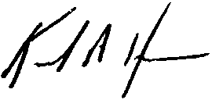
Approved By:

Keith Hovan
President and Chief Executive Officer

Date Deleted/Superseded: _____/_____/_____
Superseded by: __________________________

Attachment A

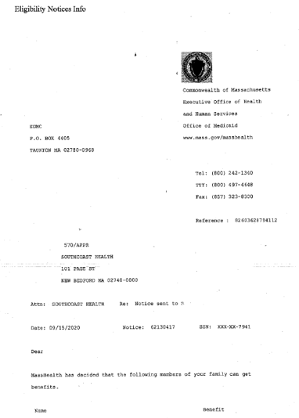

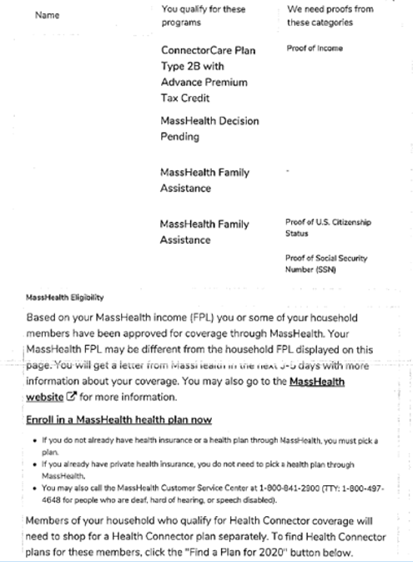

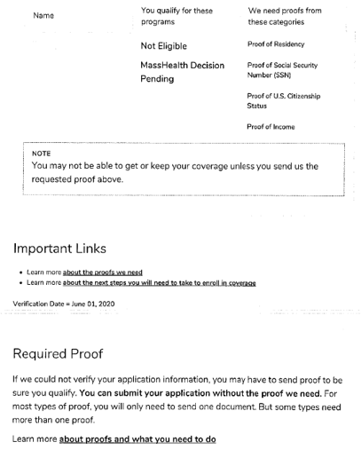

Attachment B
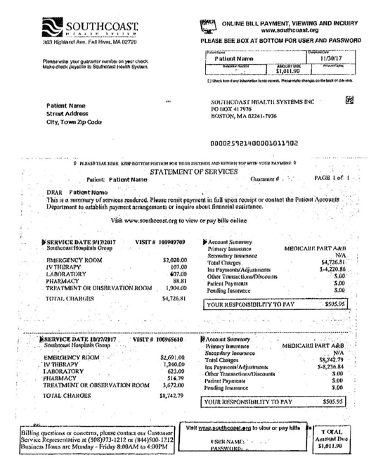
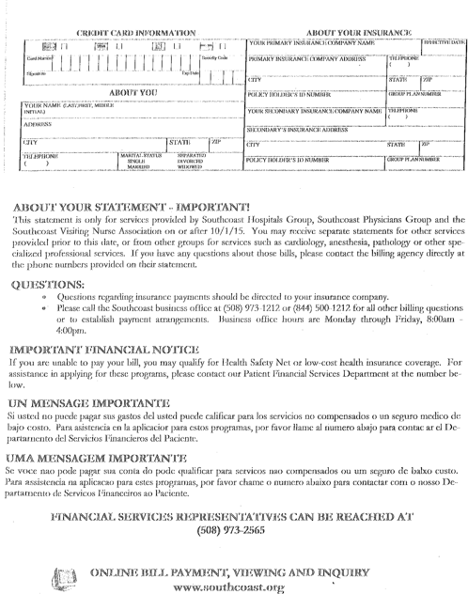

Attachment C
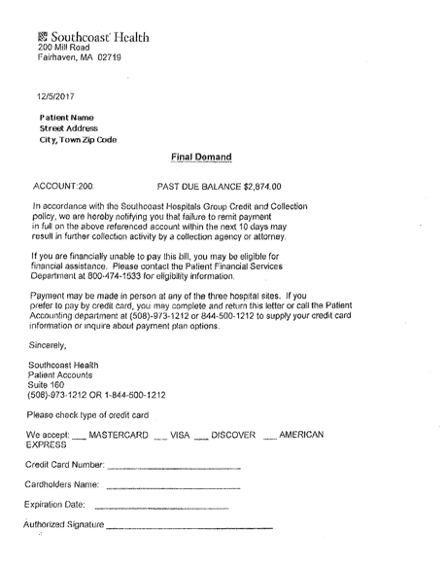

Attachment D

