I wish to become a member of The Auxiliary of Charlton Memorial Hospital.

Name: __________________
(Mr., Mrs, Miss, Ms.)
Address: ________________________

________________________

Daytime Phone: ________________________

Evening Phone:
________________________

Email___________________

Annual dues are $25.00
(billed every October)

Please make your check
for $25.00 payable to
CMH Auxiliary and mail to:

The Charlton Auxiliary
363 Highland Avenue
Fall River, MA 02720

DATE JOINED

____________________________

SPONSOR:

________________________

Revised 11/15

For more information about becoming an
Auxilian or to volunteer at Charlton Memorial Hospital, please call the Philanthropy Department at
(508) 973-7537.

The Auxiliary of
Charlton Memorial Hospital


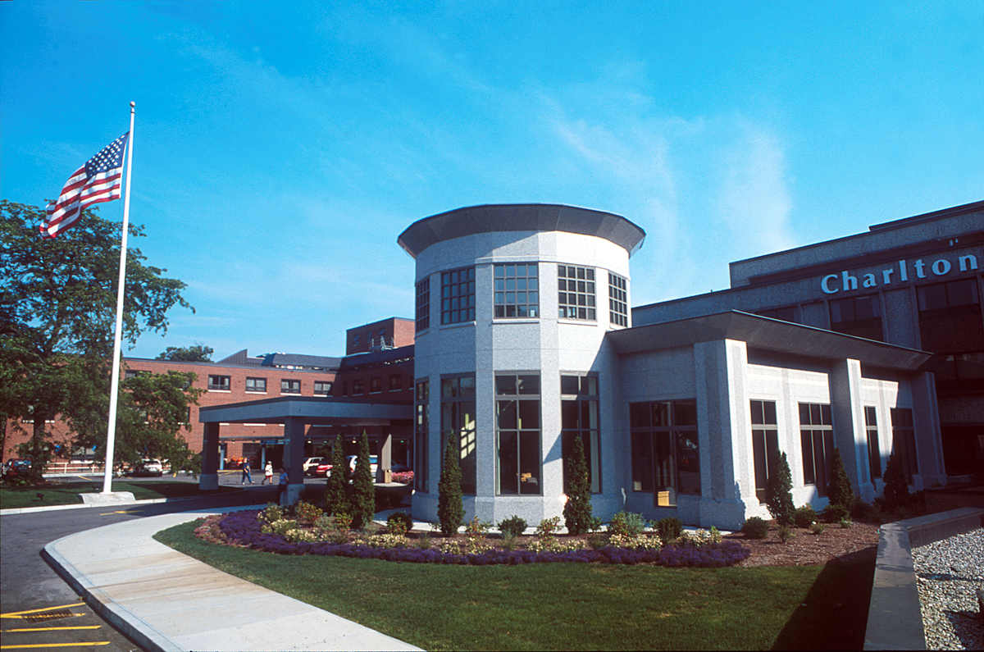

“A great way to become involved in your community hospital”

